**Before starting:**

- Log in to an ArcFM 10.2.1 machine

- Open ArcCatalog

- Make sure you turn on the schematics extension.

**Step #1:** Create connection to the database to be updated as the EDGIS user. The TNS needs to be set to the standardized generic TNS entry of “EDSCHM”

Example from system test we used:

EDSCHM =

(DESCRIPTION =

(ADDRESS_LIST =

(ADDRESS = (PROTOCOL = TCP)(HOST = edgisdboradev02.comp.pge.com)(PORT = 1521))

)

(CONNECT_DATA =

(SERVICE_NAME = EDSCMA2D)

)

)

Screen shot of connection:

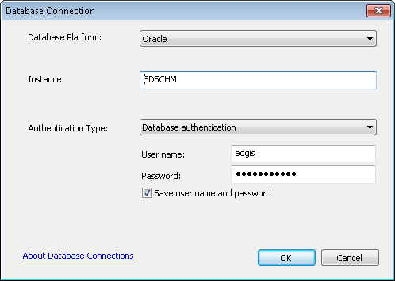

**Step #2:** Right click on the connection and choose to connect

**Step #3:** Once connected, double click on the ED_SCHEMATICS schematics dataset

**Step#4:** Right click on the ED_SCHEMATICS schematics dataset and choose Edit.

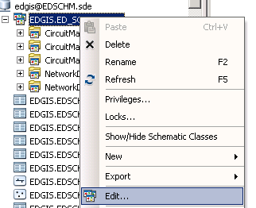

**Step #5:** If prompted, open for editing.

**Step #6:** Expand the CircuitMap group and repeat the following steps 7-8 on each of these feature class objects:

CAPACITORBANK

DEVICEGROUP

DISTBUSBAR

DYNAMICPROTECTIVEDEVICE

ELECTRICDISTNETWORK_JUNCTIONS

ELECTRICSTITCHPOINT

FAULTINDICATOR

FUSE

OPENPOINT

PRIMARYGENERATION

PRIMARYMETER

PRIMARYRISER

PRIOHCONDUCTOR

PRIUGCONDUCTOR

SECOHCONDUCTOR

SECONDARYGENERATION

SECUGCONDUCTOR

SERVICELOCATION

SMARTMETERNETWORKDEVICE

STEPDOWN

STREETLIGHT

SWITCH

TIE

TRANSFORMER

TRANSFORMERLEAD

VOLTAGEREGULATOR

**Step #7:** Right click on feature class to update and choose New Attribute

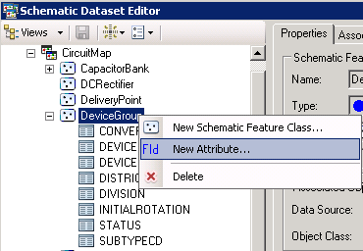

**Step #8:**  Add a Field with the following:

Name: FEEDERTYPE

Type: Associated Field

Field: FEEDERTYPE

Storage Mode: Field

Evaluation Mode: On Generate/Update

Hit OK

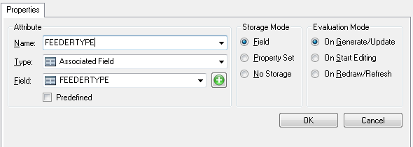

**Step #9 :** You must hit the save icon for the update to be applied.